Safer at Home - Colorado

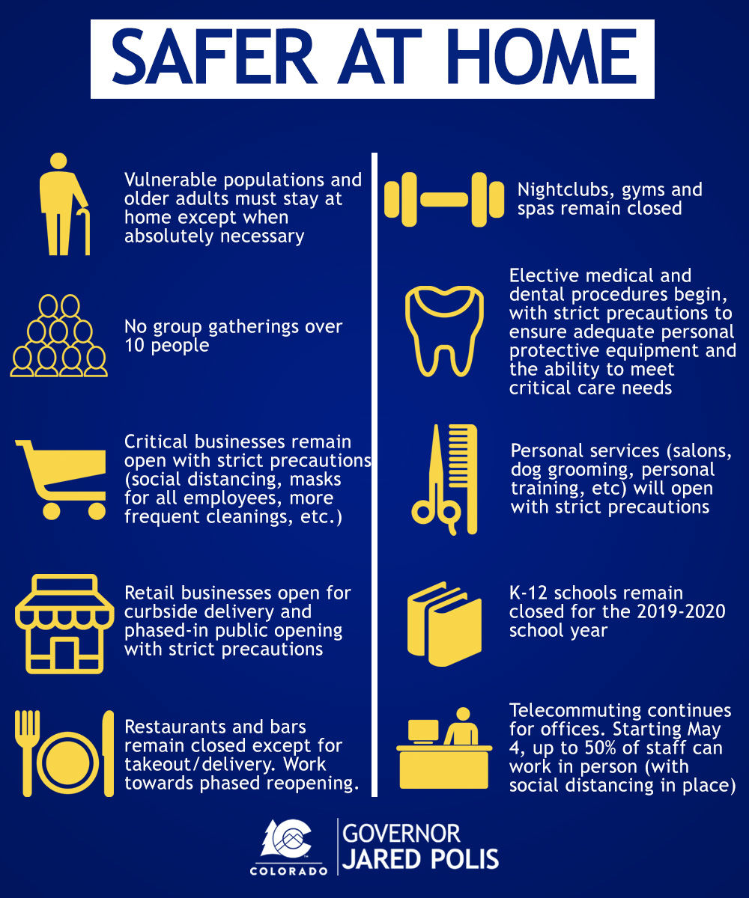
Beginning Monday, retail businesses will be able to offer curbside pickup, Gov. Polis said. Restaurants and bars will remain closed to in-person dining, he said.
Larger social environments such as nightclubs, gyms and spas will remain closed but elective surgeries and dental procedures will be available. Personal services, such as salons, tattoo parlors and personal training, will be open with "strict precautions," Gov. Polis said.
K-12 schools in Colorado will remain closed and remote learning will continue this spring. It's not yet known if at-school classes will resume next fall.
After May 4, half of staff at commercial offices can work in-person, Gov. Polis said, but telecommuting is still highly encouraged for those who can. He recommended employers stagger shifts and still implement social distancing in the office.
The goal of the Safer at Home phase is to maintain 60-65% of physical distancing, Gov. Polis said.
No gatherings over 10 people will continue to be advised after the stay-at-home order expires Sunday, April 26.
After May 4, half of staff at commercial offices can work in-person, Gov. Polis said, but telecommuting is still highly encouraged for those who can. He recommended employers stagger shifts and still implement social distancing in the office.
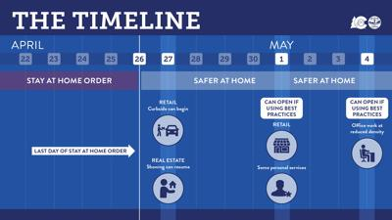

Colorado will not "in any way be going back to normal" during the second phase of battling the coronavirus pandemic when the state's stay-at-home order is lifted Sunday, said Gov. Jared Polis.
At the Wednesday briefing, the governor sought to explain what phase two — "Safer at Home" — means for Coloradans who are "chomping at the bit" to get life back to normal, reiterating the state will need to reopen gradually so as to not cause a second wave.
"Safer at Home for Coloradans means we need to continue to limit our social interactions to the greatest extent possible, to just individuals in your household, same as before," Polis said. For the most vulnerable, he added, "May is going to look just like April."
Here's what Safer at Home looks like.
Beginning Monday, retail businesses will be able to offer curbside pickup, Gov. Polis said. Restaurants and bars will remain closed to in-person dining, he said.
Larger social environments such as nightclubs, gyms and spas will remain closed but elective surgeries and dental procedures will be available. Personal services, such as salons, tattoo parlors and personal training, will be open with "strict precautions," Gov. Polis said.
K-12 schools in Colorado will remain closed and remote learning will continue this spring. It's not yet known if at-school classes will resume next fall.
After May 4, half of staff at commercial offices can work in-person, Gov. Polis said, but telecommuting is still highly encouraged for those who can. He recommended employers stagger shifts and still implement social distancing in the office.
The goal of the Safer at Home phase is to maintain 60-65% of physical distancing, Gov. Polis said.
No gatherings over 10 people will continue to be advised after the stay-at-home order expires Sunday, April 26.
After May 4, half of staff at commercial offices can work in-person, Gov. Polis said, but telecommuting is still highly encouraged for those who can. He recommended employers stagger shifts and still implement social distancing in the office.
Recent modeling from the Colorado School of Public Health showed that extending the stay-at-home order for up to four weeks would delay the peak of the virus, Polis said, but would have a negligible impact on the severity of the peak.
"It inflicts very severe economic pain on people, but also hurts the will and psychological ability of the people of Colorado to be in this for the long haul in exchange for really no reduction in the number of (intensive care unit) beds we need at the peak of the crisis," he said.
County health departments will have flexibility to either relax or tighten the state public health guidelines, Polis said. If individual counties want to relax the guidelines, they will have to fill out a waiver and prove having a low coronavirus case count.
The goal of the Safer at Home phase is to maintain 60-65% of physical distancing, the governor said. He warned that maintaining social distance is critical to the state's success.
"(Safer at Home) is not any kind of free-for-all," Polis said. "It's not an opportunity to go out and get the virus and spread the virus ... it's not an excuse to turn this into some kind of vacation."
The governor likened the gradual opening to ski terminology, warning that if Coloradans don't adhere to the social distancing measures, the state may be forced to "go back to the bunny hill."
"We're on the bunny hill right now," he said. "We're not doing blue runs or blacks or double blacks. We're keeping it gradual here and when we're ready for this challenge, we're going to do it and we're not going to fall down and hurt ourselves. ... I'm doing this to make a point. We need to manage our expectations and manage our behavior in the coming months."
More specific guidelines for business owners are expected to be addressed in the coming days, Polis said.

