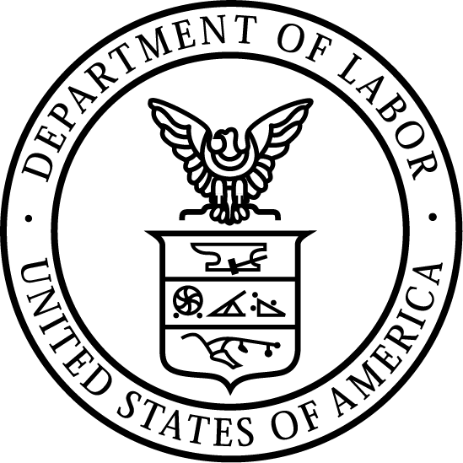
News Release
U.S. Department of Labor | March 24, 2020

U.S. Department Of Labor Publishes Guidance Explaining Paid Sick Leave And Expanded Family and Medical Leave Under
The Families First Coronavirus Response Act

WASHINGTON, DC – Today, the U.S. Department of Labor’s Wage and Hour Division (WHD) announced its first round of published guidance to provide information to employees and employers about how each will be able to take advantage of the protections and relief offered by the Families First Coronavirus Response Act (FFCRA) when it takes effect on April 1, 2020.

FFCRA will help the United States combat and defeat COVID-19 by giving all American businesses with fewer than 500 employees funds to provide employees with paid leave, either for the employee’s own health needs or to care for family members. The legislation will ensure that workers are not forced to choose between their paychecks and the public health measures needed to combat the virus while at the same time reimbursing businesses.

The guidance – provided in a Fact Sheet for Employees, a Fact Sheet for Employers and a Questions and Answers document – addresses critical questions, such as how an employer must count the number of their employees to determine coverage; how small businesses can obtain an exemption; how to count hours for part-time employees; and how to calculate the wages employees are entitled to under this law.

“Providing information to the American workforce is a top priority for the Wage and Hour Division,” said Administrator Cheryl Stanton. “With so many workers and so many employers struggling to find their way in these trying conditions, providing guidance on a rolling basis will allow workers and businesses to prepare for the law to go into effect on April 1, 2020. We remain committed, and are working around the clock to provide the information and tools for employees and employers alike.”

The guidance announced today is just the first round of information and compliance assistance to come from WHD. A workplace poster required for most employers will be published later this week, along with additional fact sheets and more Q&A.

WHD provides additional information on common issues employers and employees face when responding to COVID-19, and its effects on wages and hours worked under the Fair Labor Standards Act and job-protected leave under the Family and Medical Leave Act at https://www.dol.gov/agencies/whd/pandemic.

For more information about the laws enforced by the WHD, call 866-4US-WAGE, or visit https://www.dol.gov/agencies/whd.

For further information about COVID-19, please visit the U.S. Department of Health and Human Services’ Centers for Disease Control and Prevention.

WHD’s mission is to promote and achieve compliance with labor standards to protect and enhance the welfare of the nation's workforce. WHD enforces federal minimum wage, overtime pay, recordkeeping and child labor requirements of the Fair Labor Standards Act. WHD also enforces the Migrant and Seasonal Agricultural Worker Protection Act, the Employee Polygraph Protection Act, the Family and Medical Leave Act, wage garnishment provisions of the Consumer Credit Protection Act and a number of employment standards and worker protections as provided in several immigration related statutes. Additionally, WHD administers and enforces the prevailing wage requirements of the Davis Bacon Act and the Service Contract Act and other statutes applicable to federal contracts for construction and for the provision of goods and services.

The mission of the U.S. Department of Labor is to foster, promote and develop the welfare of the wage earners, job seekers and retirees of the United States; improve working conditions; advance opportunities for profitable employment; and assure work-related benefits and rights.

# # #

Media Contact:

Emily Weeks, 202-693-4676, weeks.emily.c@dol.gov

Release Number: 20-512-NAT

